**Design of shift registers**

Flip-flops are primitive components of a shift register or any sequential logic. Figure 1 shows the symbol of a D-type flip,-flop and how it works. Flip-flops are sensitive to the edge of a clock. The reset signal is usually active low, means that when it is in Low (‘0’) logic the flip-flip is in reset state.

At reset state, the output Q is in Low (‘0’) position and Q_N, which is NOT of the Q is in High (‘1’) position.

The reset is asynchronous to the clock. Means that when active (‘0’), the outputs will go the reset state regardless of clock position.

When RESET_N pin is not active, i.e. in High (‘1’) position, the output Q gets the value of the input D at the rising edge of the clock and holds this value until updated at the rising edge of the next clock.

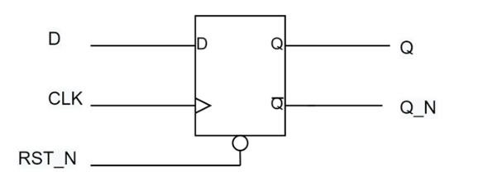

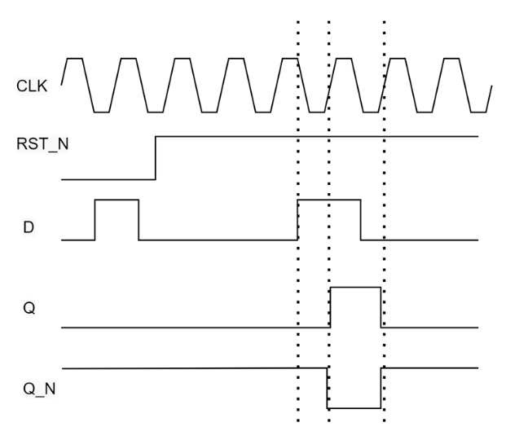

Figure 1: D-type flip-flop

The Verilog description of the above flip-flop is shown in Block 1.

Block 1: D flip-flop Verilog code

**module** dff

(

**input** i_d,

**input** i_clk,

**input** i_rst_n,

**output** o_q

);

**reg** r_q;

**assign** o_q = r_q;

**always**@(**posedge** i_clk **or** **negedge** i_rst_n)

**begin**

**if**(!i_rst_n)

r_q<= 0;

**else**

r_q<=i_d;

**end**

**end**

**endmodule**

Block 2, suggests a test-bench for the flip-flop

`timescale 1ns/1ns

**module** dff_tb();

**reg** r_d, r_clk, r_rst_n;

**wire** w_q;

**integer** i;

dff uut(

**.**i_d(r_d),

**.**i_clk(r_clk),

**.**i_rst_n(r_rst_n),

**.**o_q(w_q)

);

**initial**

**begin**

r_clk = 0;

r_rst_n = 0;

r_d = 0;

#10 r_rst_n = 1;

**end**

**always** #10 r_clk <= ~r_clk;

**initial**

**begin**

**for**( i= 0; i< 10; i=i+1)

#24r_d <= ~r_d;

**end**

**endmodule**

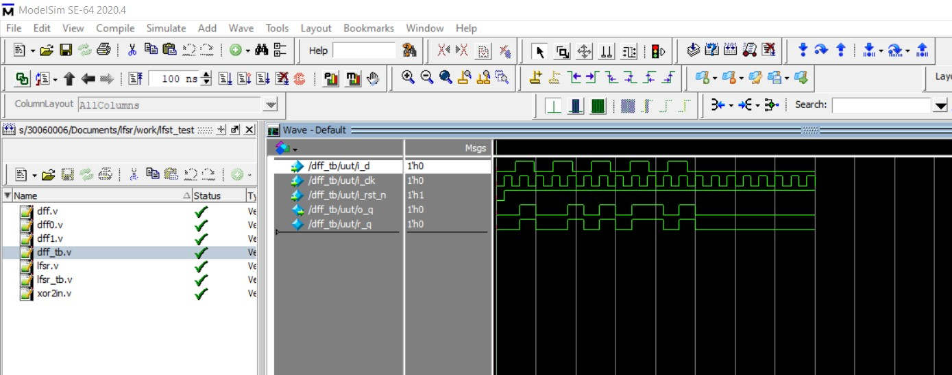

Figure 3: ModelSim simulation of the D flip-flop

Now, if we connect the clock and reset of two flip-flops together and the output of the first one to the input of the next, we will have a two bits shift register (Figure 2). The input D, will appear at the output Q2 of the second flip-flop after two clock pulses (two rising edge of the clock). Why?

Draw the waveform for the shift register in Figure 2.

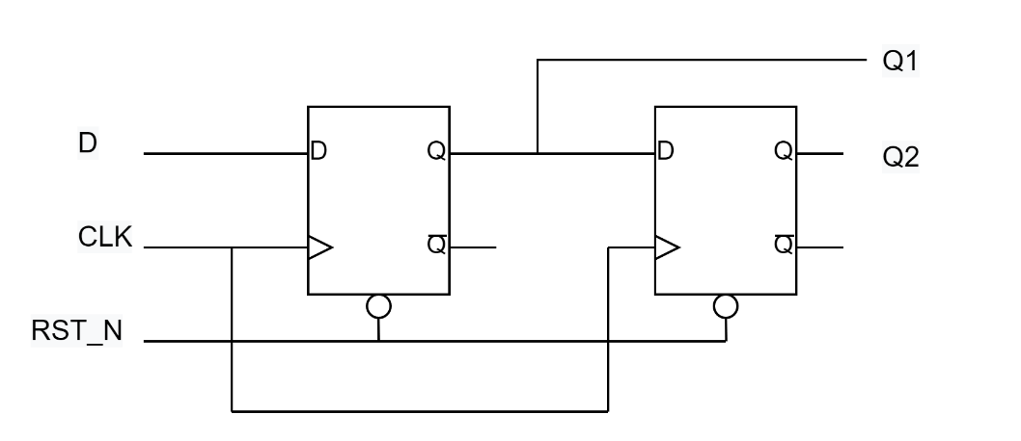

Figure 2: A 2-bit shift register

Write the Verilog code, and test-bench for the shift register in Figure 2, and run the simulation to see how it works.

Expand your shift register to four bits and re-run the simulation.